Mechanical Devices – Advanced Thermal Solutions
Mechanical-Devices is a leading manufacturer of thermal management systems (Temperature Forcing System) for the semiconductor industry - with extensive experience in thermal analysis and in the development of sophisticated thermo-mechanical systems for temperatures monitoring.
The systems are plug & play, stand-alone, and do not use water, air or LN2 for cooling or heating.
They allow for wide temperature forcing across a range of devices, sizes and types, whether socketed or soldered to the board.
The unique technology allows for wide thermal ranges, -75°C up to 200°C, and support for a power dissipation range of 0-700 watts.

The well proven thermal head methodology creates a stable temperature control environment right where you need. The pneumatically driven thermal head makes direct contact with the IC device providing great power handling and precise temperature control.

These advanced thermal systems provide significant advantages over existing solutions available today:
- Compact size
- Quiet operation
- Customized enclosures and mounting options
- Wide temperature range

Please contact us for more information or to request a demo at our lab in Kanata, On.

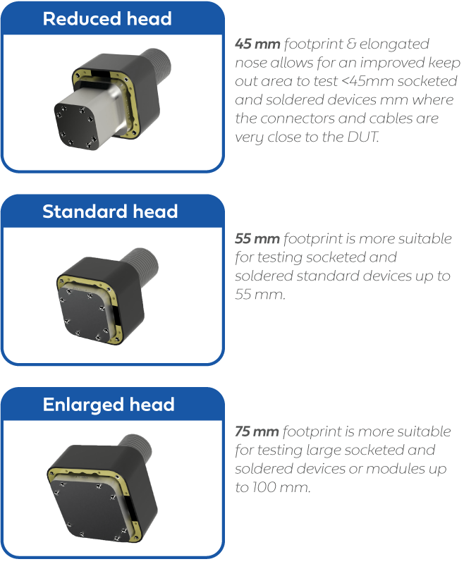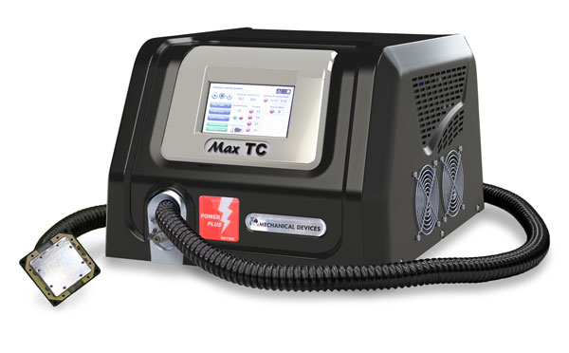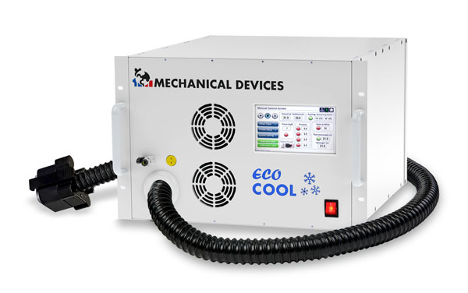
Most of the Semiconductor industry enjoy Mechanical-Devices systems worldwide. We are dedicated to the highest manufacturing standards and quality assurance. Our systems are CE compliant and we offer worldwide service and support. Our factory is of the latest innovation and accommodates all demands.

